**Pause for a second, and lets discuss the console**

This is a tangent

This specific lecture has little to do about the CRP, or even AJAX for that matter.

But as you have just seen in the previous lecture, we used the console to view our window object (remember, this is where we found the Ajax object).

A student of mine (thanks Antje) asked a related question about the console, and it got me thinking about sharing something with you that not many people know about.

In fact, there’s hardly any discussion on this on the web and I have not found any documentation about it anywhere.

Maybe its because nobody really cares (haha), but in any event I thought I’d put something together and share it with you.

DevTools is your new home

When you code, you will be in the **DevTools**a lot.

And often you’ll be dealing with objects that you can expand.

Like the Window object for example.



And as you travel further down the rabbit hole, chances are you want to open up this object and explore all of its properties and methods.

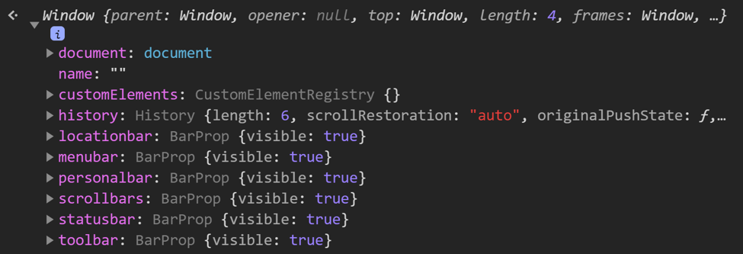

Simple enough.

You’ll notice that each property is in a funky bright purple color.

But here's the thing.

If you scroll to the bottom, these properties suddenly get dimmed out.

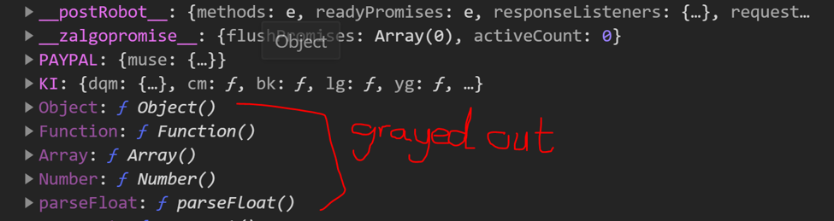

WHAAAAT?

Exactly. I just wanted to share with you why I think these are dimmed out.

It may not be technically correct but it’s how I think about dimmed properties whenever I see them.

REMEMBER, this is not a crucial lecture and its relatively advanced. Feel free to skip over it if its hard to follow.